Microsoft Robocopy GUI
Users Guide
Version 3.1.1

Table of Contents
Version 3.1.1 1
1 Requirements 2
2 Installation 3
3 Commands 7
3.1 Path Tab 7
3.2 Copy Options 8
3.3 Drive Mapping 9
3.4 Filters 10
3.5 Logging 11
3.6 Monitoring Options 12
4 Uninstall 13

Requirements
- Windows 2003, Windows XP or Windows 2000 Operating System.
- .NET Framework 2.0
- Latest release of Robocopy.exe (Installed with Robocopy GUI 3.1.1)

Installation
- Double-click on setup.exe or setup.msi
- Click Next. (see figure 1)

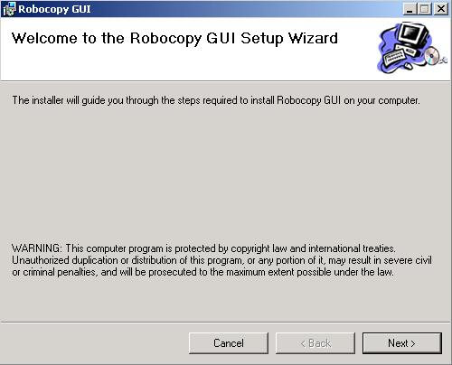
Figure 1
- Read the license agreement and if you choose to agree click I Agree and then click Next. (see Figure 2)

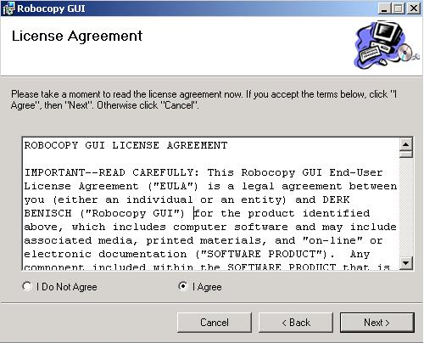
Figure 2
- Choose which folder you want to install the Microsoft Robocopy GUI to. We recommend that you accept the defaults. (see Figure 3)

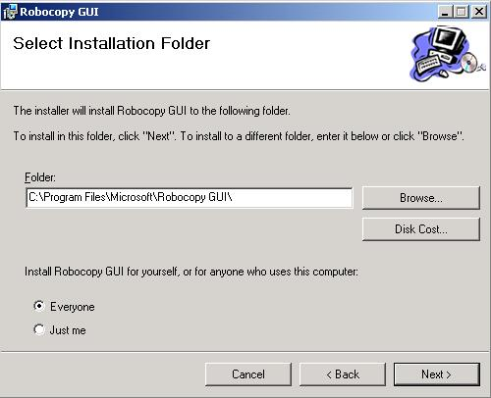
Figure 3
- Click Next to confirm your setup. (see Figure 4)

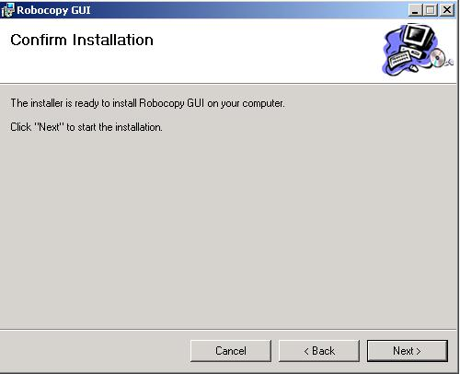
Figure 4
- The installation of the Microsoft Robocopy GUI will now start. You can view progress by watching the progress bar on the installation screen. (see Figure 5)

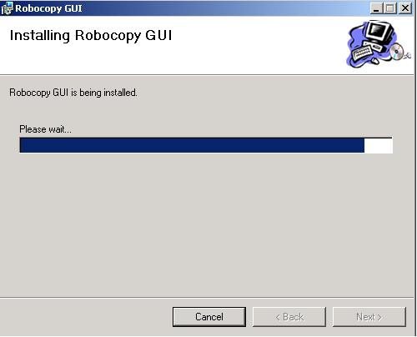
Figure 5
- When installation is complete, click Close to exit the setup.

Commands

Path Tab
This is where you will specify the source and target path’s which you would like to have copied. If you don’t know the exact path, you can click on the browse button at the end of the path box (see Figure 6). This will bring up a folder browser dialog box which will allow you to click on the folder that you would like to copy or copied to.
If your target path is a remote server, you can click on the Map Drive checkbox and specify the path. If you specify a remote path, all you need to specify is the drive letter and folder path, you don’t need to specify the server name. The server is specified under the “Drive Mapping” tab. NOTE: Be sure to specify the drive mapping options on the “Drive Mapping” tab.
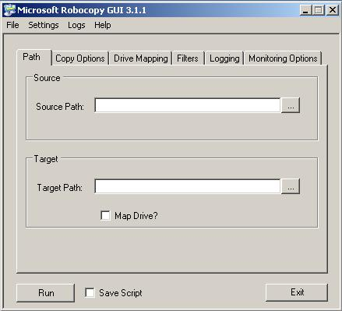
Figure 6

Copy Options
The Copy Options tab is where you can specify the behavior you would like robocopy.exe to take. This guide will not cover what each option or combination of options will cause the robocopy.exe to do. We provide a copy of the Robocopy Users Guide with the installation of the Microsoft Robocopy GUI. Alternatively, you can hover your mouse over each option and after a brief pause, a description of what the option will do will appear. (see Figure 7)
For more details about each option, see the Robocopy.exe Users Guide (Click on Help > Robocopy Users Guide).
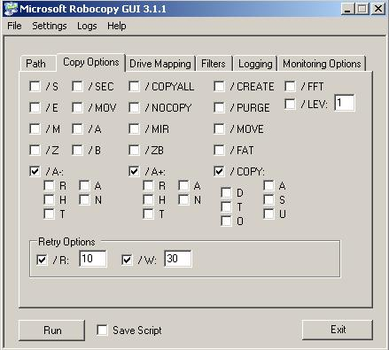
Figure 7

Drive Mapping
If you have specified on the “Path” tab that you would like to map a network drive, this tab is where you will specify the target server name, user name, password and domain. If your target server is not a part of a domain, you will need to specify the server name in this field. (see Figure 8)
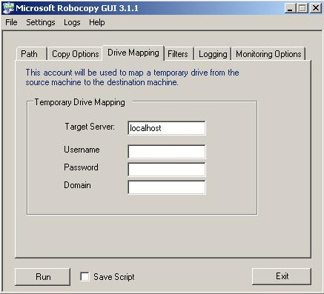
Figure 8

Filters
The Filters tab is where you can specify more advanced behaviors you would like robocopy.exe to take. This guide will not cover what each option or combination of options will cause the robocopy.exe to do. We provide a copy of the Robocopy Users Guide with the installation of the Microsoft Robocopy GUI. Alternatively, you can hover your mouse over each option and after a brief pause, a description of what the option will do will appear. (see Figure 9)
For more details about each option, see the Robocopy.exe Users Guide (Click on Help > Robocopy Users Guide).

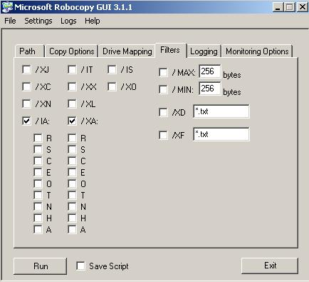
Figure 9

Logging
The Logging section is used to specify logging behavior that robocopy.exe will take when the script is ran. (see Figure 10)
For more details about each option, see the Robocopy.exe Users Guide (Click on Help > Robocopy Users Guide).
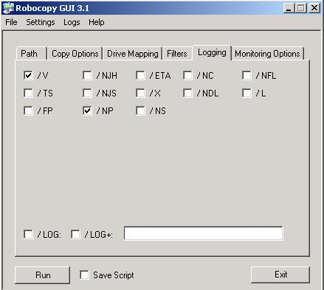
Figure 10

Monitoring Options
If you would like to take advantage of some of the new options presented in the latest version of Robocopy.exe, this section will allow you to set monitoring and “near real-time” options. (see Figure 11)
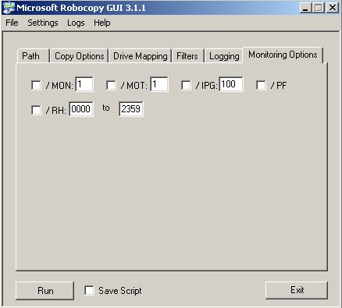
Figure 11

Uninstall
In order to uninstall the Microsoft Robocopy GUI, you need to open your Control Panel and then Add / Remove Programs. Choose the Microsoft Robocopy GUI and click Remove. This will permanently remove the Microsoft Robocopy GUI from your system.

